HYPER TEXT MARKUP LANGUAGE:

HTML

PRIYADHARSHINI R

17:06:2023

12.00 PM

HTML (HYPER TEXT MARKUP LANGUAGE)

EXERCISE 1:

HTML,HEAD,BODY TAG:

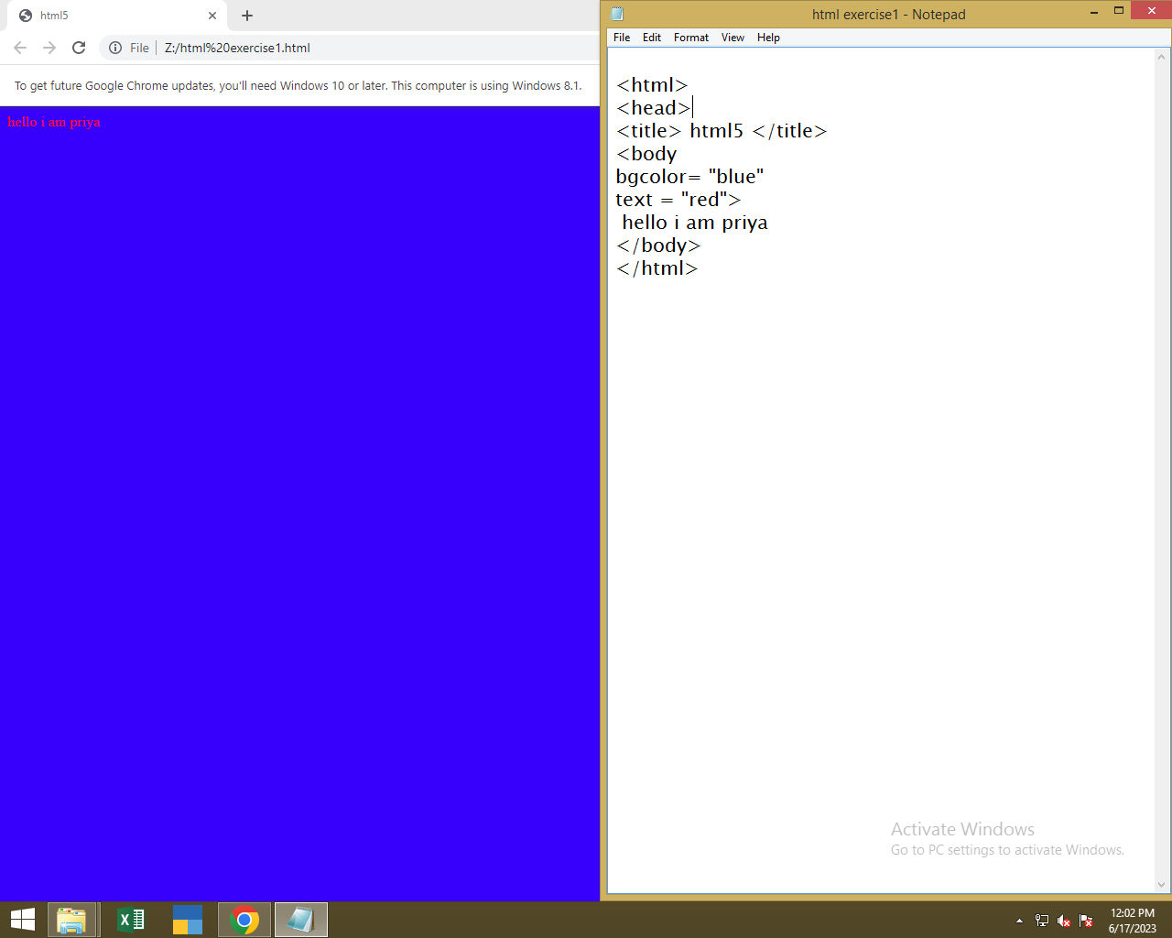

EXERCISE 2:

HEADING TAG:

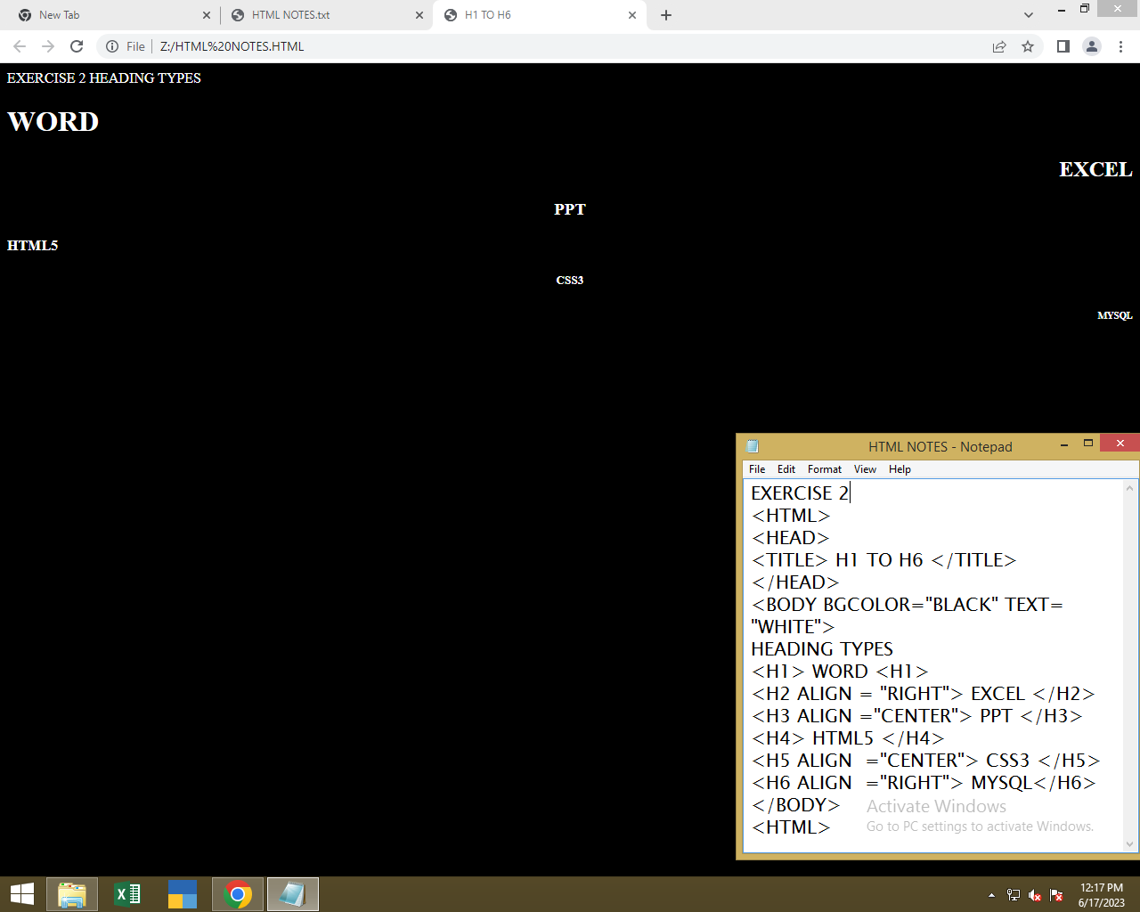

EXERCISE 3:

STYLE USING HTML 5:

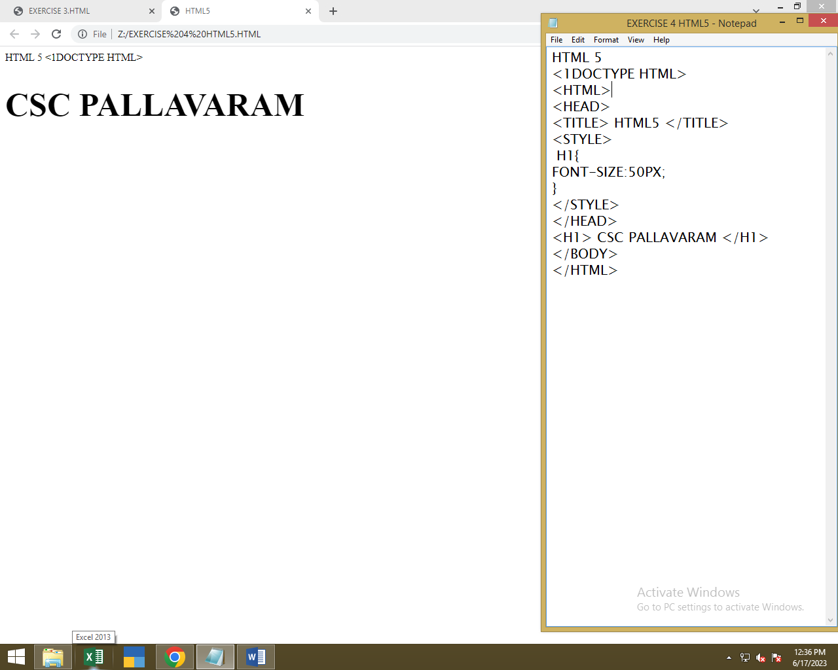

EXERCISE 4:

DIV TAG AND ASIDE TAG:

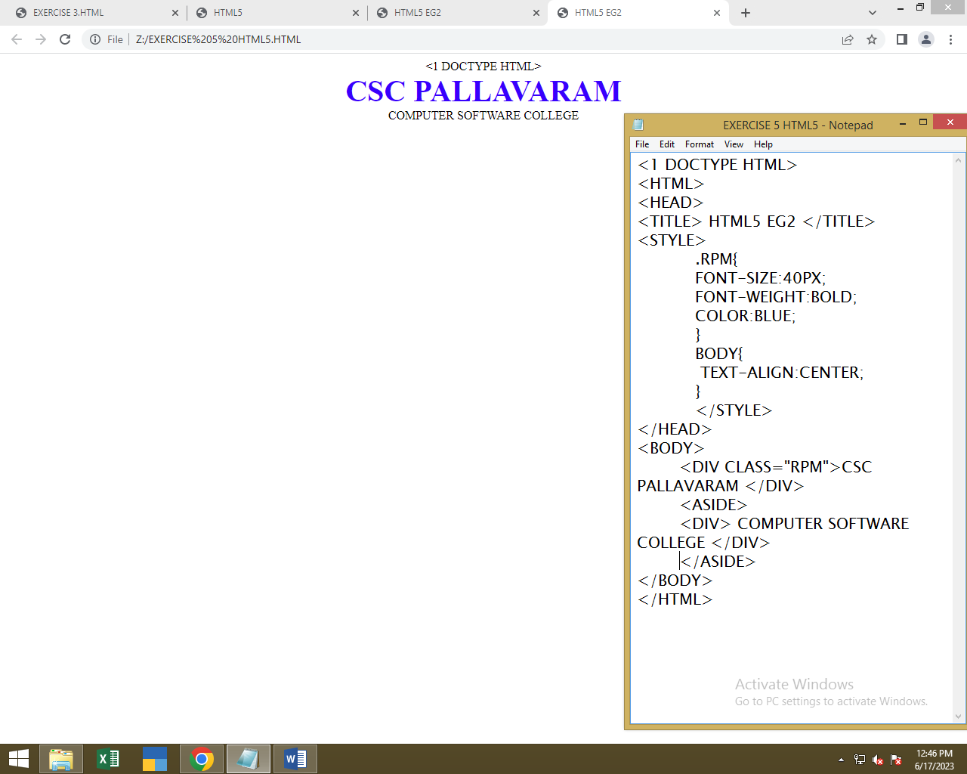

EXERCISE 5:

IMAGE TAG:

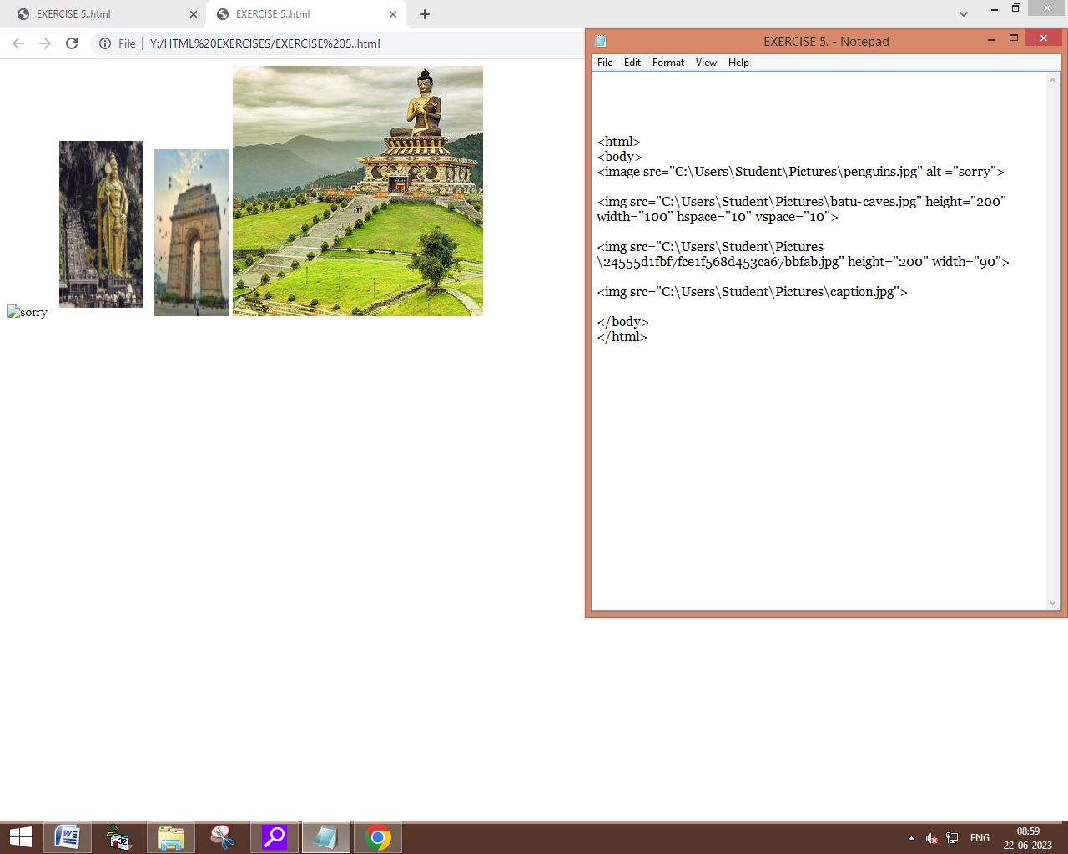

EXERCISE 6:

LIST TAG:

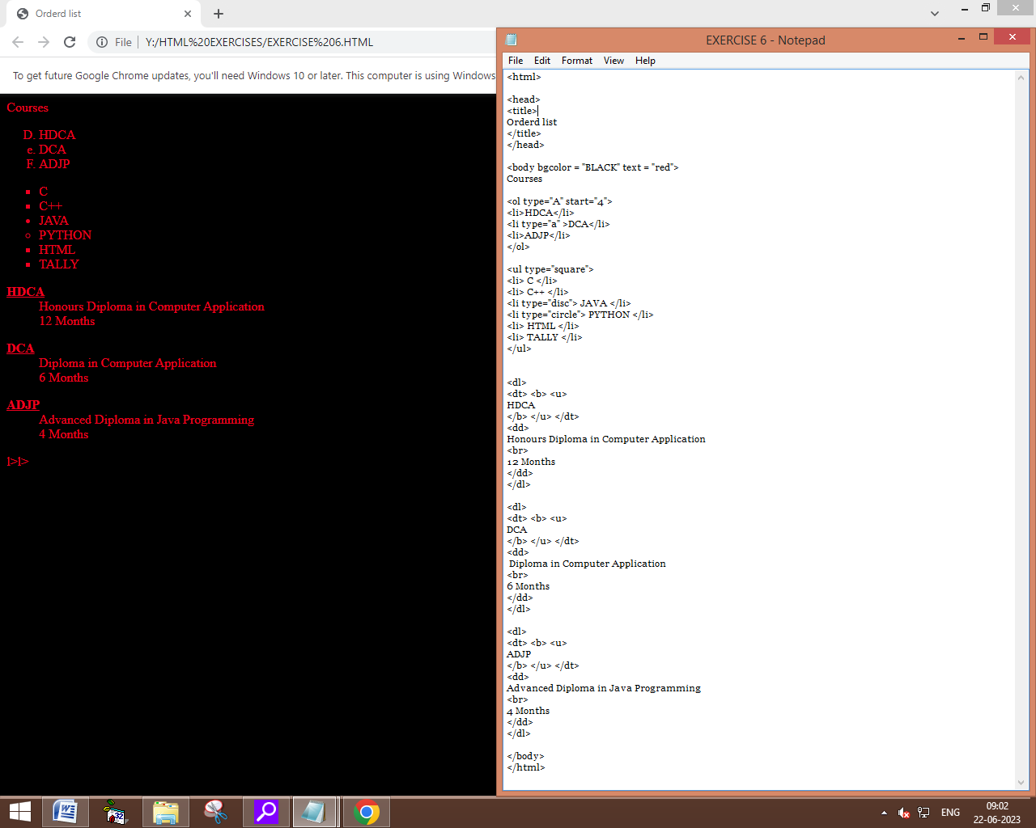

EXERCISE 7:

ANCHOR TAG:

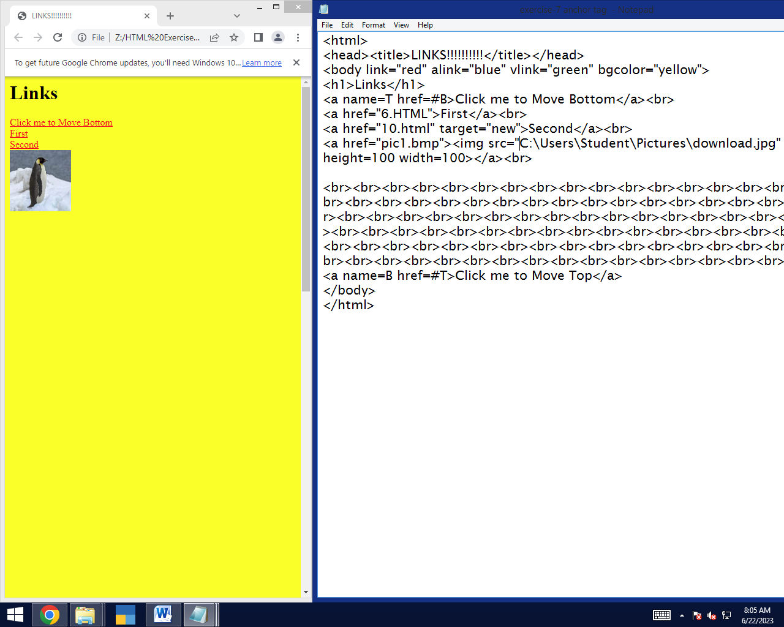

EXERCISE 8:

TABLE TAG:

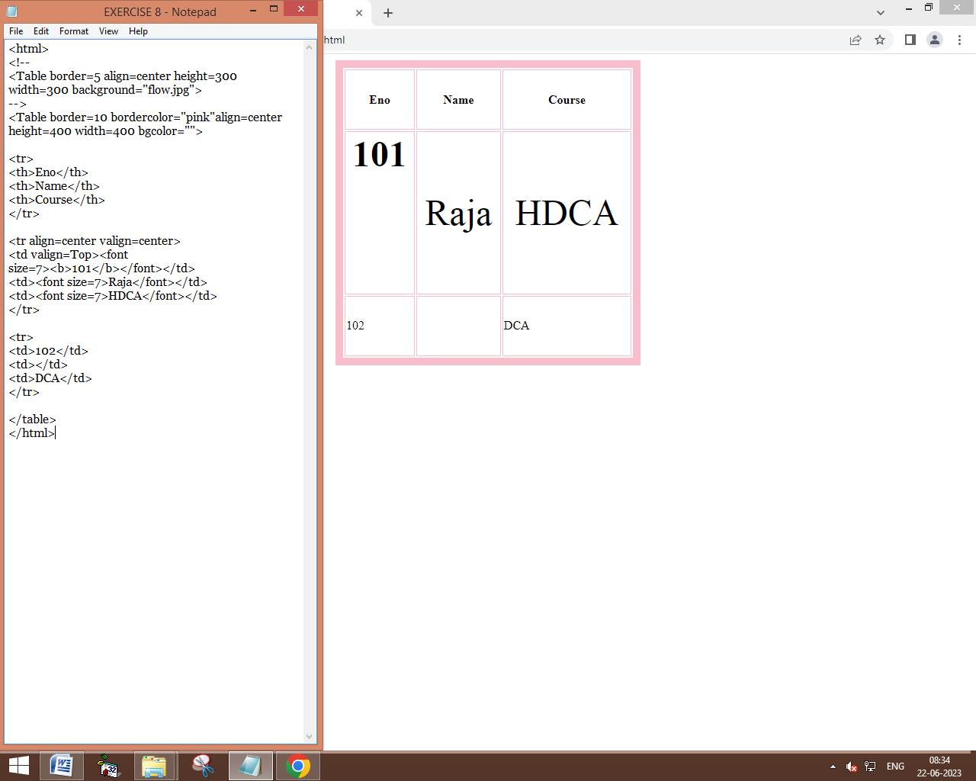

EXERCISE 9:

INPUT TAG:

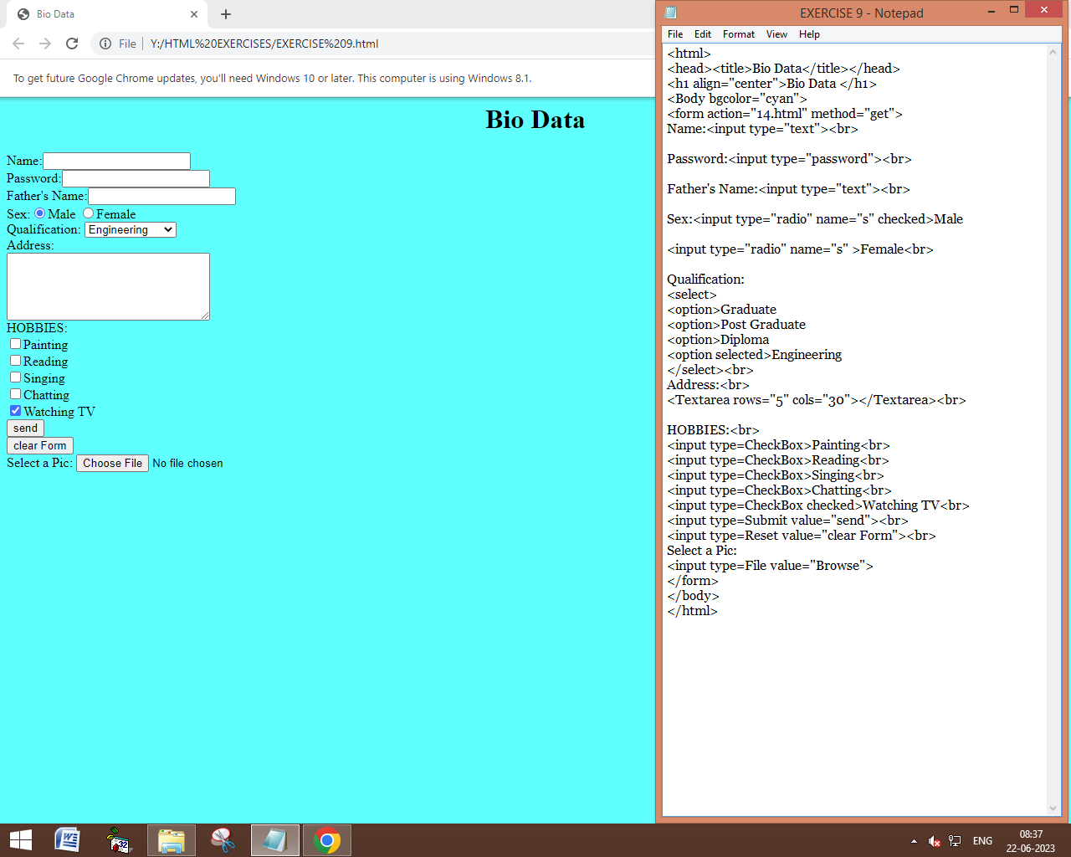

EXERCISE 10:

AUIDO TAG:

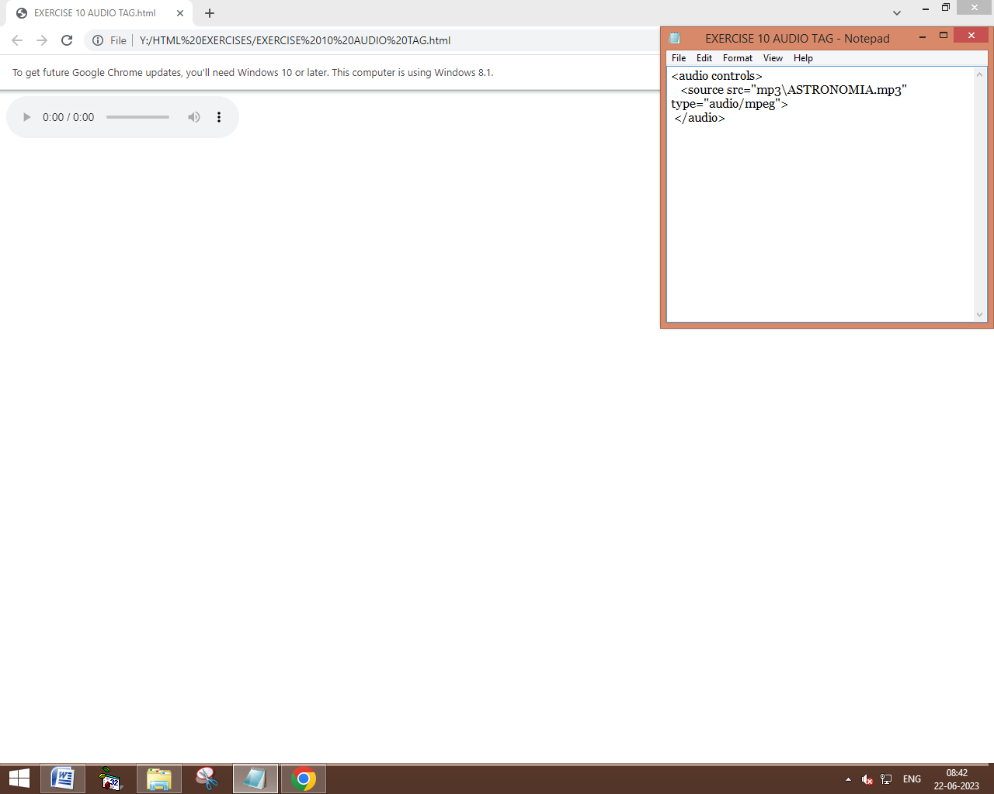

EXERCISE 11:

VIDEO TAG:

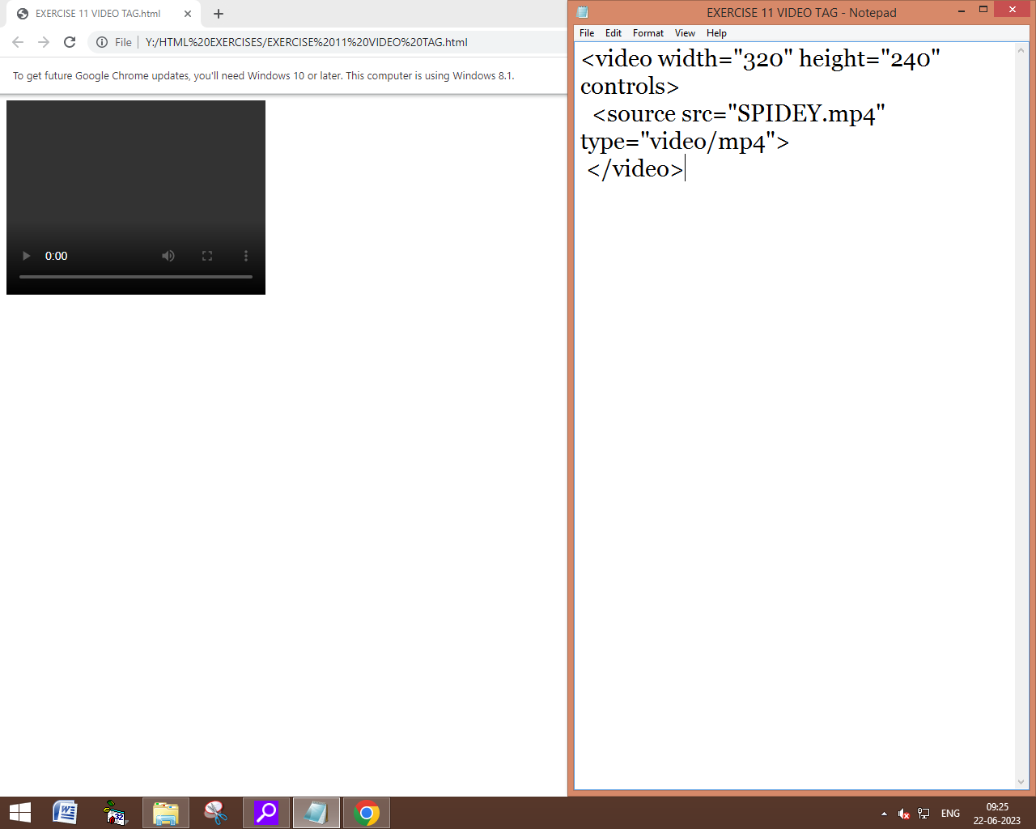

EXERCISE 12:

QUOTATION TAG:

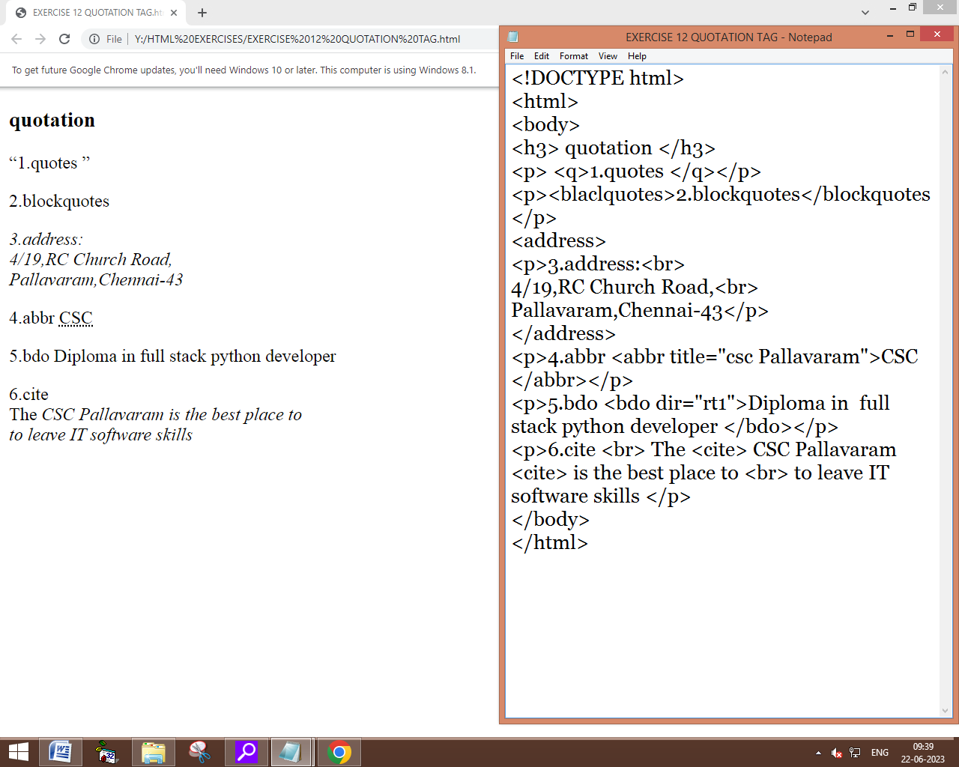

EXERCISE 13:

SPELLCHECK:

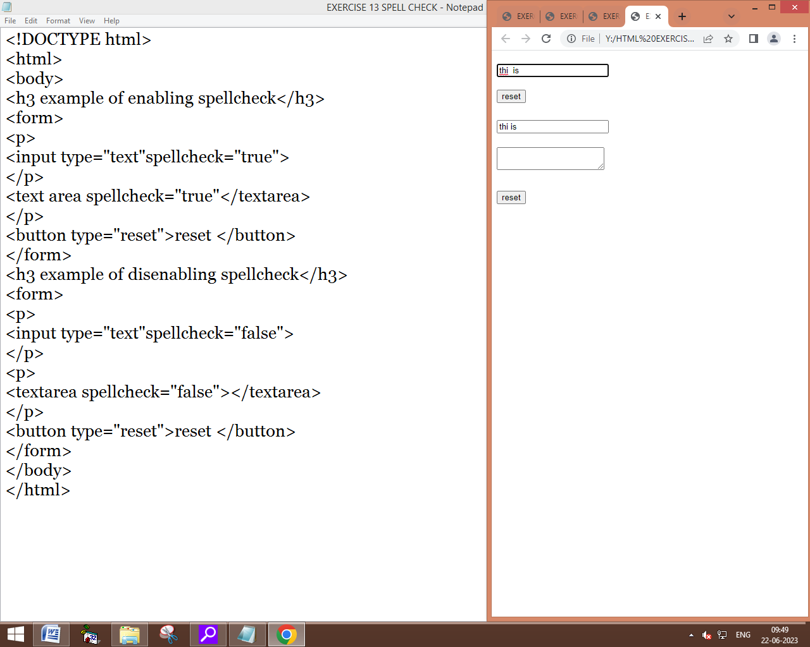

EXERCISE 14:

color style and hsl:

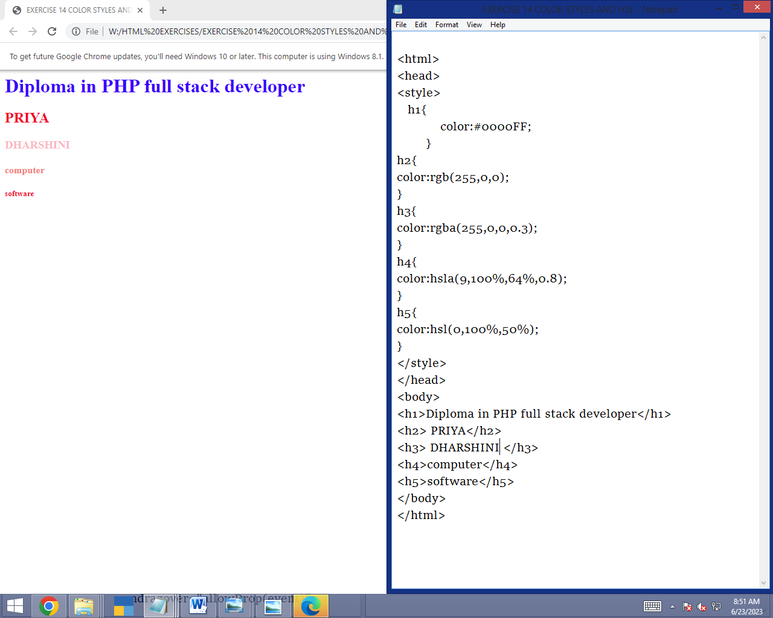

exercise 15:

geo location:

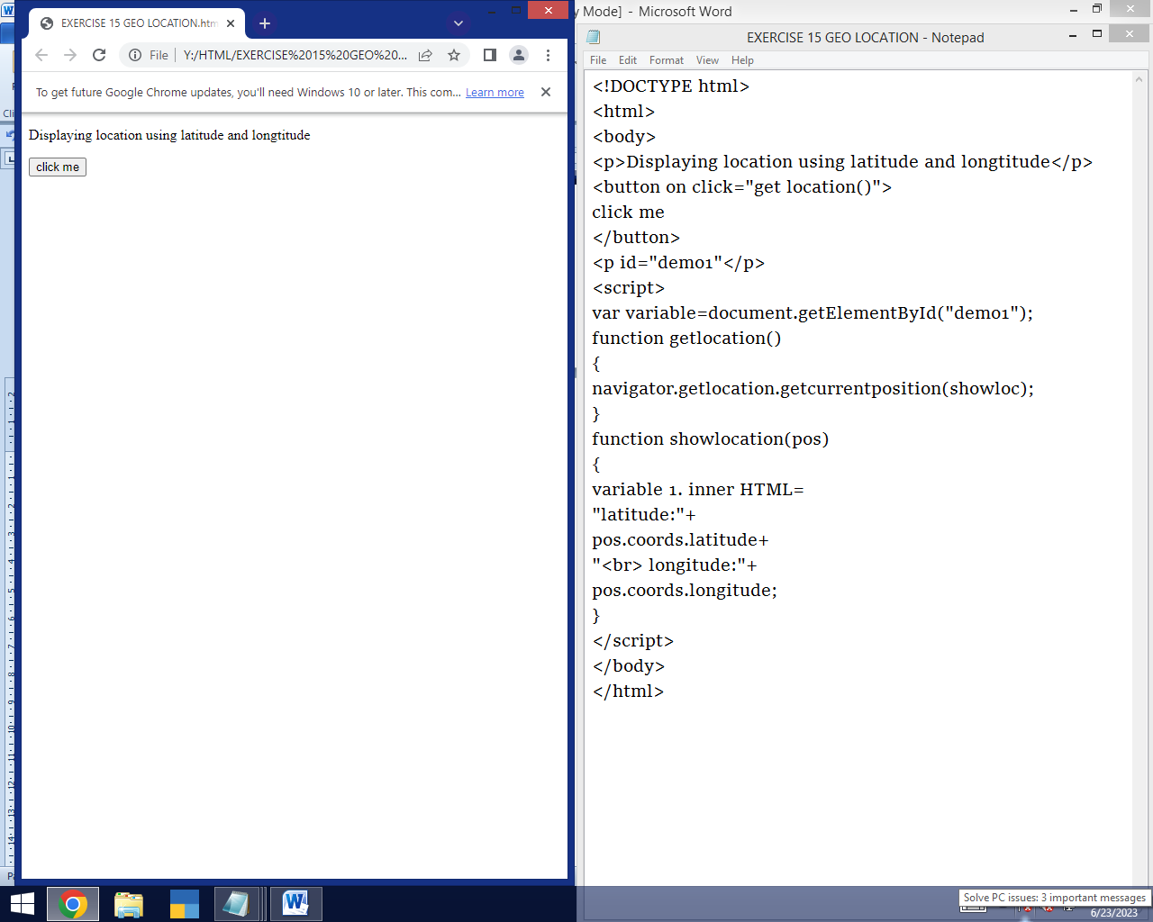

EXERCISE 16:

DRAG AND DROP:

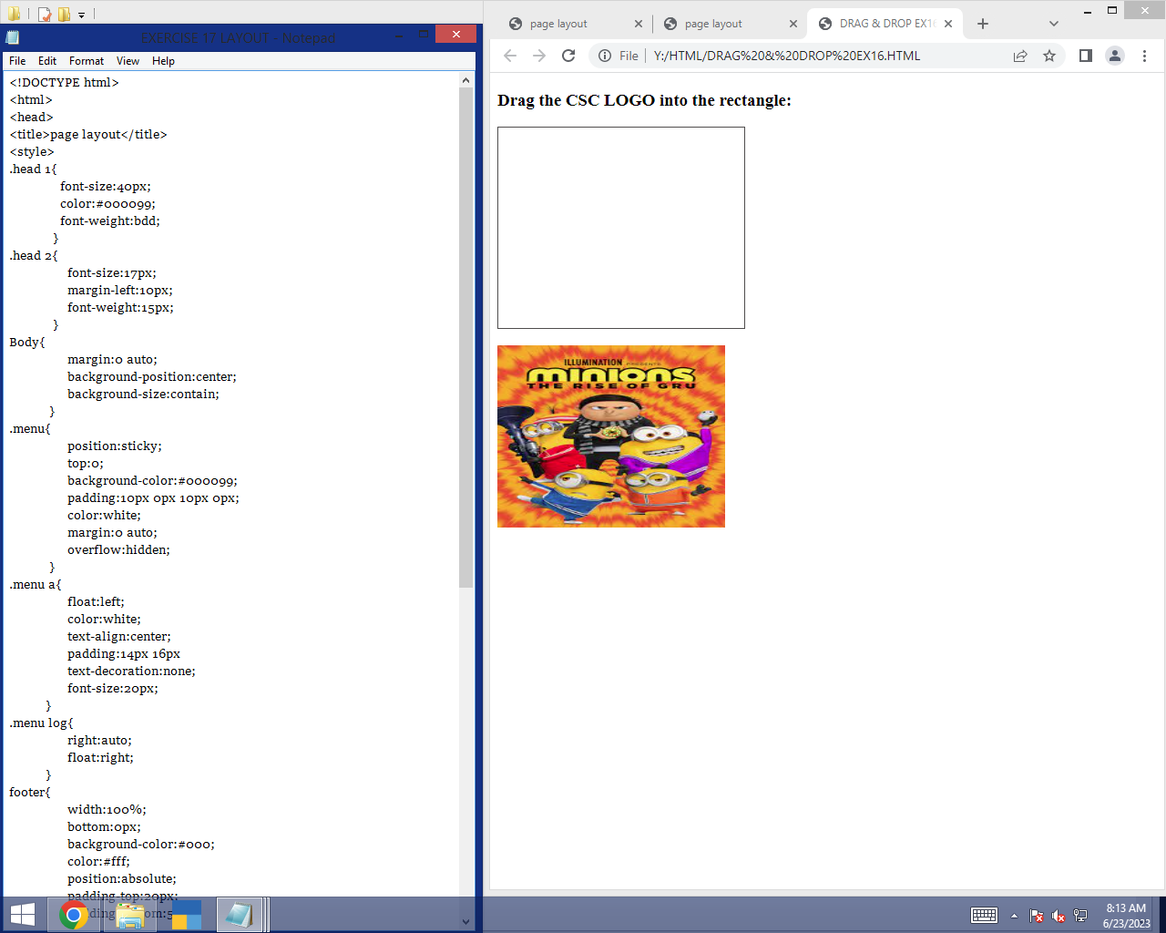

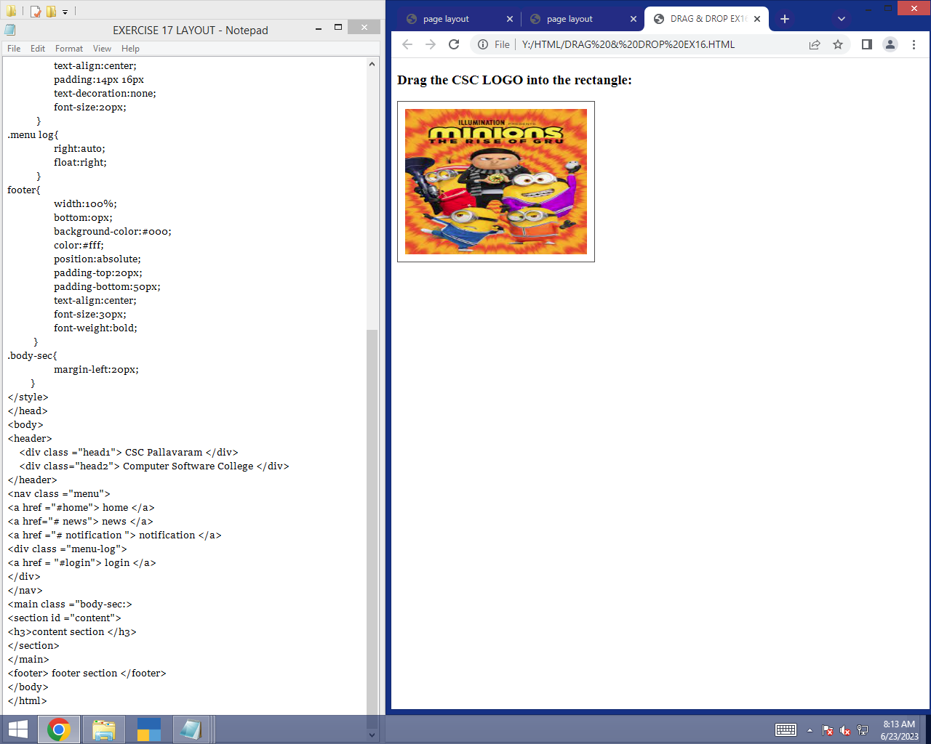

EXERCISE 17:

LAYOUT:

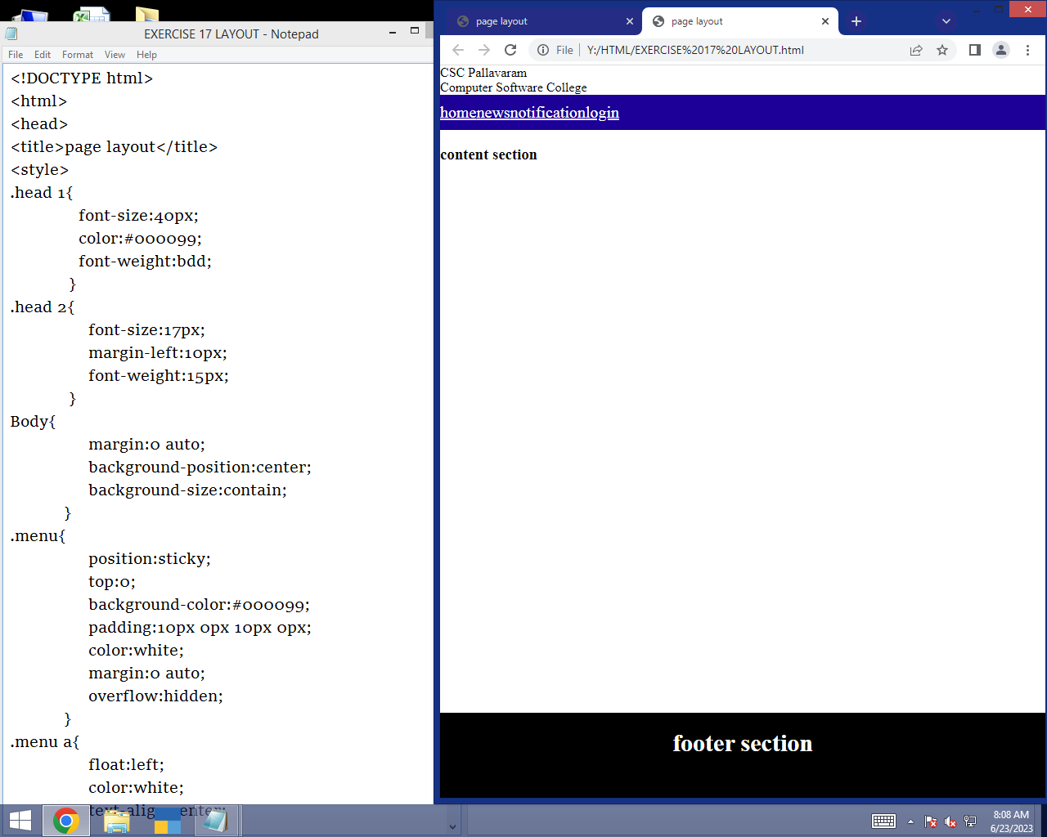

EXERCISE 18:

CANVAS:

EXERCISE 19.1:

SHADOW EFFECT:

EXERCISE 19.2:

ROTATE:

EXERCISE 20:

IMAGE USING CANVAS:

